

**By**

**Sunil Raj Thota**

**Sashank Yakkali**

**Feng Gao**

**Date: 06/24/2021**

**Title: XN Sponsor Deliverable**

**ALY 6080 – Integrated Experiential Learning**

**Prof. Atherley, Valerie**

**Introduction:**

We have a responsibility to achieve and stick to in this endeavor. As strategy can be described in development, project managers must graphically express the goals of the project and critical deadlines. In this case, plan benchmarks help a bit. They help employees understand the objectives of the project, targets, assets, and scheduled outcomes, which are all represented on a timetable. Make a range of important operations that will develop to the next target on the roadmap.

To establish the direction in which required tasks should be directly regulated on interconnections and corporate strategy, we are using the method outlined below. Determine how much work and attention each output will take. Consider factors in the utilization of funds and group members, as well as any prospective risks and hazards the project to fail. There should be separate objectives one per accomplishment.

**Project Requirements**

We will go closer to the Annual Conc. By Monitor in 2020 Dataset, that was collected again from EPA site, in this activity. Every component is determined in its place. EDA equips you with the capacity to see past the figures. As we delve even more into the material, we obtain more ideas. We'll conduct exploratory research in this manner. For about 80% of our work, we'll have used EDA to analyze information to solve multiple business challenges. This is used to maintain pace with the evolution over through the course of 24 hr and regulate things as needed. R/ Python will be used to investigate the collection. We also used ER Visits Dataset to see the patterns and correlations between the 2 datasets. The goal is applied and followed to perform Machine Learning models to anticipate higher AQI and make reports using tools like Power BI, Tableau, and AWS Quick Sight beyond the model to evaluate it. We'll be looking at a couple of columns in the future. Our preferred way of visual analytics is the Graphics Panel.

**Milestones**

As we set few milestones in previous weeks and met them are:

* We have followed all the Deadlines of the project
* Kept in touch with stakeholders
* Key Performance Indicators (KPIs) have been targeted
* Progress is made in a step-by-step manner
* Assessed our development
* Resolved the problems
* Nearing to complete and present the project

These milestones enabled the group to determine which activities would lead them in the right direction to meet these objectives.

**Job Assignments**

We are a three-person team. Each of us needs to develop some flexibility and capacity to work on all of the duties that we will be presenting. The job will be assigned to a person who will be responsible for completing it while adhering to the timeframes and quality standards. This way, we'll all be aware of what's going on with the project, and it'll be simple to assess where we stand

.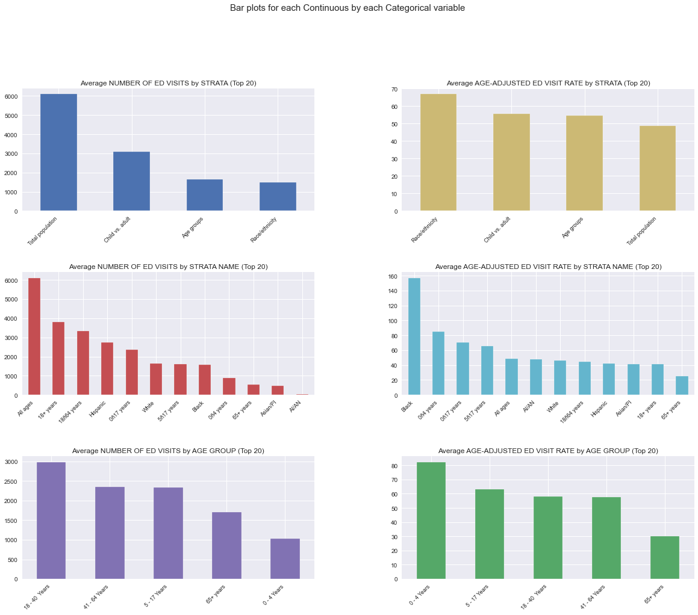

As we did not analyze the ER Data before, We got a major update in our project analysis by doing some deeper analysis and modeling on the ER Dataset.

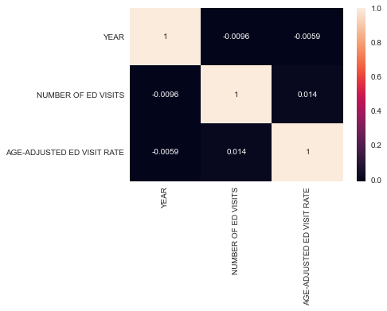

We also plotted the correlation between the Year, No. of ED Visits, and Age-adjusted ED Visit rate.

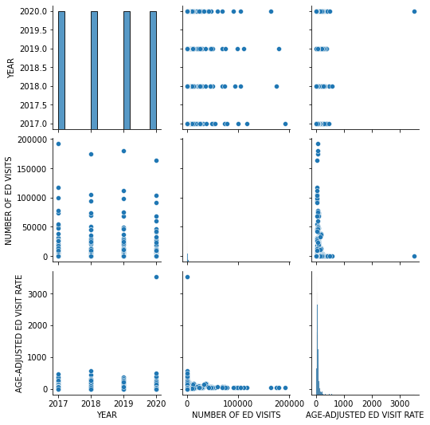

**Risks and Strategies**

The most challenging component, in our opinion, is the evaluation. We must ensure that our team will work together to create a product or service. Before any assessment process can begin, the stakeholders of the failing project must first draft and sign a charter. We believe we are aware of the obligations in this circumstance. Project efforts usually go to waste when specifications are imprecise and there is no sufficient communication with sponsors/clients regarding the progress done so far and whether they are satisfied or not.

One of the risks we notice is a lack of awareness. The greatest risk in making such predictions is that the future environment may change, and so the past may not be enough to predict the future. Even if the core analytics team is small, engaging with as many other colleagues as possible to acquire additional perspectives on their point of view is beneficial. Getting the proper data, interpreting models effectively, and asking the right questions of the production all require a great deal of creativity, business expertise, and experience.

**Measure of Success**

A methodical approach has been beneficial towards the conclusion of a level because it shows how the activities of the project in comparison to the previous estimates. Analyze the main anniversaries to determine if they all fall along with the same dates. A high accuracy will establish whether or not what you've said is compliant with the quality plans' criteria.

By assessing project progress, you're also assessing project failure, which is equally necessary to investigate. Failure isn't the end of the world. Examine the project's final deliverables. Some projects produce excellent results but cause undue stress. Check to see if the project benefited its stakeholders.

**Presentation Method & Results**

By evaluating the data, we generate a Monitor in one of the applications and get some suggestions for improving Keva Health's platform. We ended up creating a few plots, which we presented to the stakeholders. Data visualization is a technique for visually examining data - in other words, using visuals to understand data. During the presentation, we discovered that some chart designs encouraged more fruitful debates. We used graphical images to help relevant stakeholders and decision-makers grasp what a dataset shows, how a strategy can fix a pain point, and what impact the discoveries will have on the firm.

**Conclusion:**

From this Assignment, we have gained lots of exposure to the health data, air now data, er visits data, got to know about the company’s strategy, plan, and respiratory health monitoring platform. We have been thriving for this project and ready to present to the company officials in the coming days. It all went well as per the guidelines created and followed by the team. As the company stakeholders asked about creating a dashboard using AWS QuickSight. We did go ahead and used that tool and made some visuals. We are also good with the results and hoping for feedback from them.

**References:**

[1] upGrad. (Jan 5, 2021). 13 Ultimate Big Data Project Ideas & Topics for Beginners [2021]. *Blog*. Retrieved from https://www.upgrad.com/blog/big-data-project-ideas-beginners/

[2] Admin. (FEBRUARY 13, 2021). Why Big Data Science & Data Analytics Projects Fail. *Data Science Project Management*. Retrieved from https://www.datascience-pm.com/project-failures/